Categories & Subcategories:

- Sub Category new Creation per Custom Furniture is selected

Seller Login:

- Email & Phone sign in options like daraz.
- Error on login should be different for invalid email/pass & Account does exist
- If email is not in records - Account does not exist
- If email & pass don't match - Incorrect user or password

Seller Registration (Partner With Us):

- Policies links not working… should be configured from back end
- Spelling of Houseology
- Password - Minimum 8 characters with a number and a letter
- Remove gender
- Phone number format is incorrect…. Mobile number place holder with local format… inspired by ntn
- OTP Not live.
- Thankyou or direct login
- Remove success stories
- Checkbox not ticking
- Terms & conditions hyperlink missing & text format
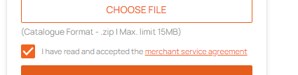
- Link to redirect to seller login
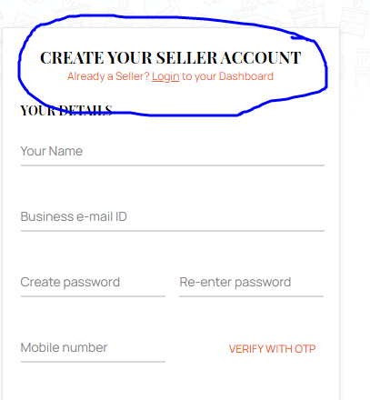
- Link to redirect to Homepage

Seller Panel Home

- Loading image pop up issues… should have closing button and static loading
- 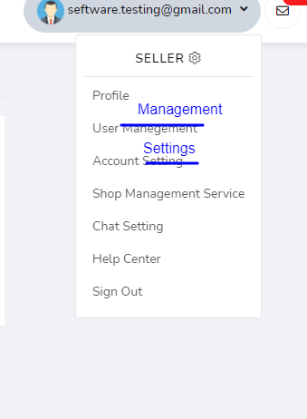
- Remove Chat setting & shop management service.. Not part of our scope at the moment
- 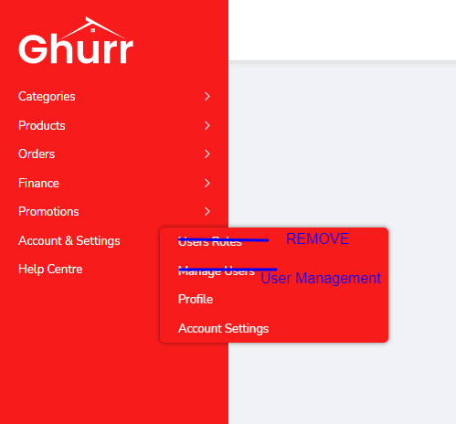
- Message centre is not live.. Its showing demo data…
- Add FREE SHIPPING module in promotions
- Account Settings will only have option to change profile photo and password.. Remove all extra things.. Refer daraz

Product Uploading:

- Product details should load section wise…. I.e after selection of category… Please refer daraz
- Product weight and product dimensions should only accept numerical value and not text input
- Product dimensions should be break down into l,w,h in cms
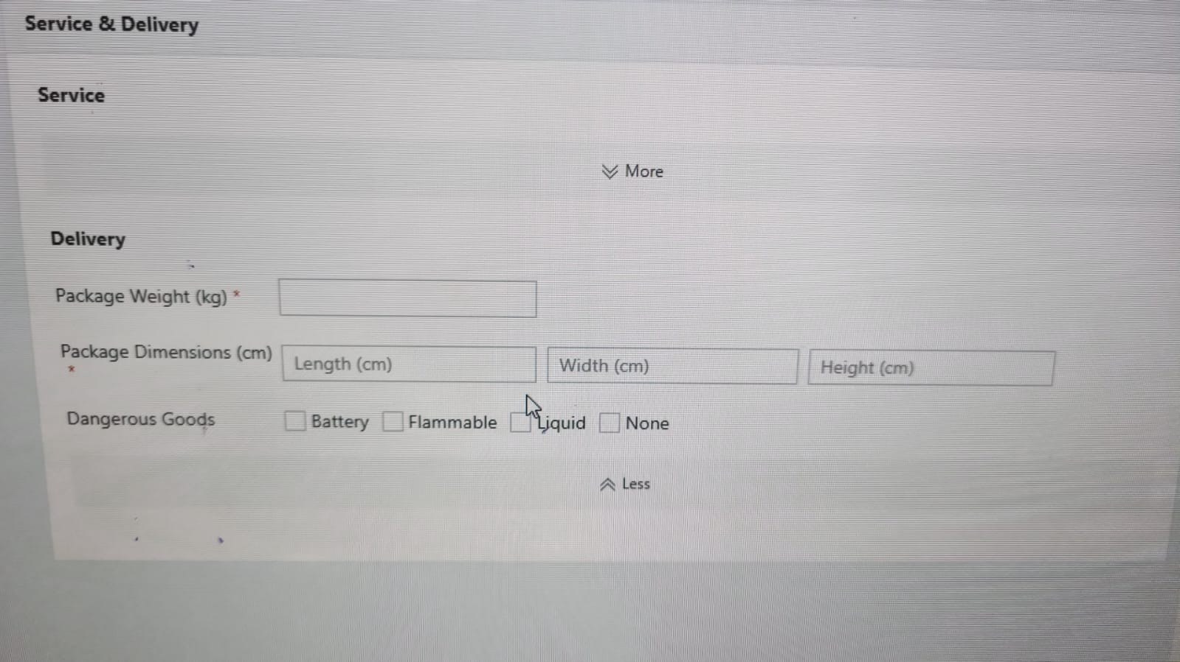
- ‘Save as Draft’ function missing…. Draft products will be shown in all products of seller.
- Product variations will have quantity in stock & active/inactive option.. Product variation will have add image option… 1 image only
- Remove add more from product variations

- 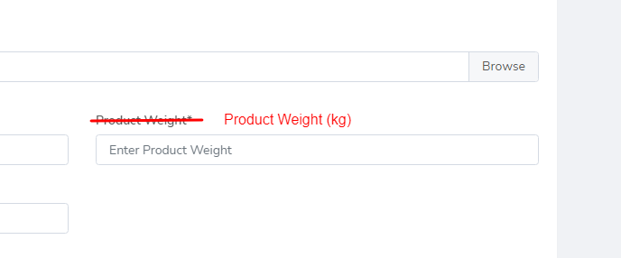
- Only upload image file or video file from computer as per requirement…. The software is currently accepting any type of file for image and video.. I can upload a document too
- 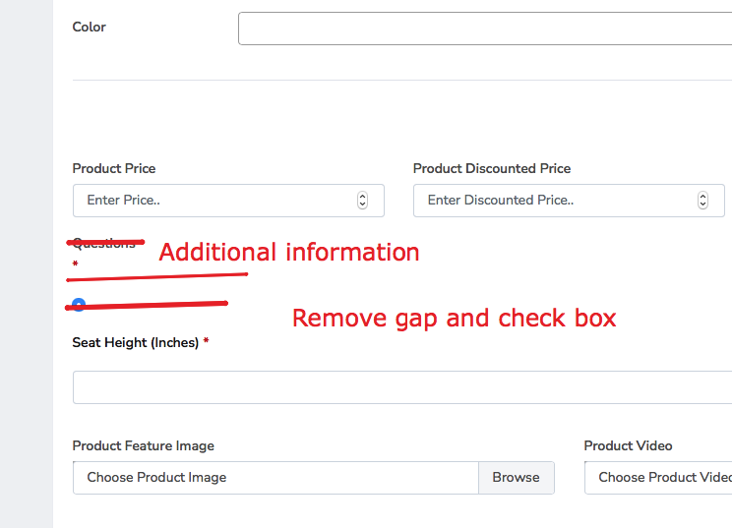
- 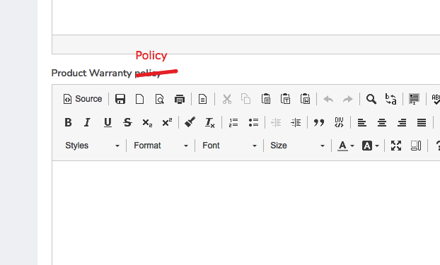
- Product care instructions will be preset from admin panel in each category
- Product warranty will be set by seller in his settings.

Customer login:

- FB Login not working

Create my account - Customer
- Create an account by email or phone number… not both… select either..
- Phone/Email verification code missing
- Phone Number format to be fixed with prefix and number format
- Date of birth year format is incorrect… its accepts 5 digit entry
- DOB is accepting future date… Min age should be 12 years old
- Remove address from initial registration
- Form layout
  - Full Name*
  - Email/Phone Number* - Either one with verification
  - Gender*
  - Birthday*
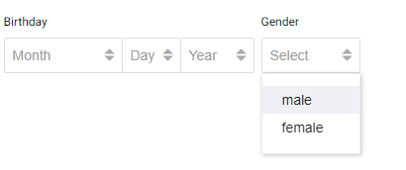
  - Password*

Field | Error (If no input) | Error (Invalid Input)
Full Name | You can’t leave this empty. | -
Email/Phone Number | You can’t leave this empty. | Please enter a valid phone number/Email.
Gender | You can’t leave this empty. | -
Birthday | You can’t leave this empty. | -
Password | You can’t leave this empty. | Minimum 6 characters with a number and a letter.

- Phone number country code and formatting.. Error if phone number format is incomplete or faulty
- Phone number/Email verification
- Cities missing.. Please use complete list
- After creating account the customer will be logged in and redirected to homepage and not his profile
- Login error not showing properly.. Use the same format and error message as seller login

Customer Portal:

- vouchers and wallet missing
- 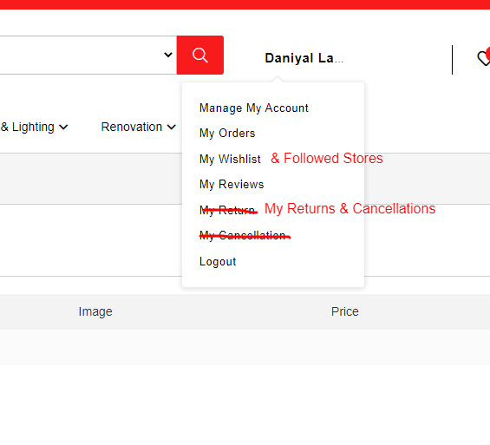
- 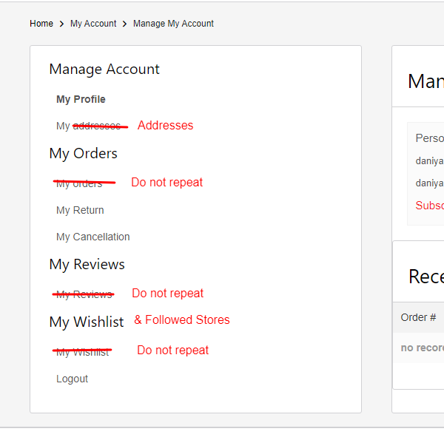
- My profile page is separate… please refer daraz…
- Manage my account, my orders, my wishlist & my wishlist are all clickable and not just headings
- Option to add and edit addresses in My Addresses missing… please refer daraz
- Option to make default shipping and billing address
- Redirected to concerned page when clicked on any edit function in manage my account…still not working properly
- Fix this in header.. The name should have a drop down menu.. Menu item list from daraz…
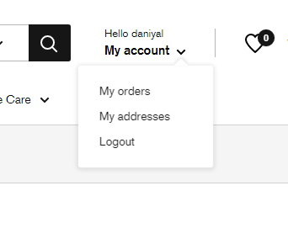
- My profile page is missing…..and has mixed with manage my account… please refer daraz
- My followed store in wishlist missing… refer daraz
- After logging in customer account, the page will not be redirected to account settings… the account will login and stay on the page that it is….. Do not redirect after logging in

